Ministry Staff:
SW Synod Bishop Dee Pederson D.D. - Southwest Synod: kristin@swmnelca.ccsend.com
Pastor Linda Wimmer: wimmerlr@gmail.com Cell: 320-297-0643
Vicar Sara: sjlgal@frontiernet.net Parsonage: 320-598-3722
Administrative Assistant Demi Roiland @ Zion: 320-289-2216
Zion:
Church Council: President Ritchie Voorhees, Vice President Matt Tollefson, Secretary Tim Ehrenberg, Lisa Johnson, Dan Smith, Kathy Tweten, Tim Beyer and Kenzie Gisvold
Treasurer: Leslie Ehrenberg
Organists: Pati Arnold, Andrea Johnson, and Marty Koosmann
Custodians: Larry and Diane Kepner
MN Valley:
Church Council: President Dale Lien, VP Kami Schoenfeld, Secretary Dawn Olson, Trustees Garrett Olson, Dean Neraasen, Mark Hastad
Communion Deacons: Gladys Hastad, Jason Lund, Don Tweet, Financial Secretary Scott Omland, Board of Education Dawn Bjorgan, and WELCA President Jane Baldwin
Treasurer: Karin Moen
Organists: Karin Moen, Dale Lien, Amber Omland
Custodians: Kristin Cam
Borgund:
Church Council: President Ron Sigdahl, VP Dane Prestholdt, Secretary Marcia Kells, Worship Dorothy Anderson & Cindy Sigdahl, Education & Activity Director Pat Redepenning, Property Committee David Redepenning
Treasurer: Tamie & Brian Bremseth
Organist: Dorothy Anderson
Service & Contact Information:
Zion Email: zlcappleton@gmail.com
MV and Borgund Email: bmvsecretary@mchsi.com
Zion Website: www.appletonzion.com
Facebook: Zion Lutheran Church
Facebook: Minnesota Valley Lutheran
KLQP FM Radio 92.1 Sundays at 1pm & 7pm
Mediacom Channel 8: 12pm Sundays MN Valley/ 3pm Appleton
YouTube: Zion Lutheran Appleton/Mn Valley Lutheran

BORGUND, MN VALLEY, AND ZION LUTHERAN CHURCH
April 16th, 2023 – Installation of Pastor Linda Wimmer
WELCOME & ANNOUNCEMENTS
THANKSGIVING FOR BAPTISM
GATHERING HYMN ELW 817 “You Have Come Down to the Lakeshore”
GREETING AND KYRIE p. 147
CANTICLE OF PRAISE p. 149
PRAYER OF THE DAY (insert)
MESSAGE FOR ALL GOD’S CHILDREN
FIRST READING: Acts 2:14a, 22-32
PSALM 16; 16:11
SECOND READING: 1 Peter 1:3-9
GOSPEL ACCLAMATION “Halle, Halle, Hallelujah” ELW 172
GOSPEL: John 20:19-31
SERMON-Pastor Naomi Mahler, SW MN Synod Pastor
HYMN OF DAY ELW 386 “O Sons and Daughters Let Us Sing” (verses 1, 5-7, 9)
APOSTLES CREED p. 105
INSTALLATION OF REV. LINDA WIMMER

PRESENTATION
ADDRESS AND QUESTIONS
Almighty God . . . . to perform them. Amen.
ADDRESS TO THE ASSEMBLY
Response (given twice): We will and we ask God to help us.
. . . and of the Holy Spirit. Amen.
BLESSING
. . . forever and ever. Amen.
PRAYERS OF INTERCESSION (insert)
PEACE
ELW 184 Let the Vineyards Be Fruitful
OFFERING PRAYER
GREAT THANKSGIVING p.152
LORD’S PRAYER p.154
BLESSING & SENDING
THREE-FOLD AMEN
SENDING HYMN ELW 723 “Canticle of the Turning”
DISMISSAL
sundaysandseasons.com.
Copyright © 2023 Augsburg Fortress. All rights reserved.

Zion
Lector: Dan Smith
Communion: Dan & Kristin Smith
Video: Tim Ehrenberg

Welcome Pastor Linda! We are so happy to have you leading us! Also thank you Pastor Naomi Mahler (SW MN Synod Pastor) for coming to join us on this special day.

ANNOUNCEMENTS
Sunday, April 16th
-10:30am Tri-Church service @ Zion
-Installation of Pastor Linda Wimmer
-11:30am POTLUCK after worship service @ Zion
Wednesday, April 19th
-1pm Zion Prayer Shawl gathering
-LAST TRI-CHURCH CONFIRMATION
Sunday, April 23rd Confirmation Sunday
-8:30am MN Valley Worship
-Treats to follow celebrating Confirmands
-10:30am Borgund Worship
-10:30am Zion Worship/come celebrate our Confirmands!!

A friendly reminder for Borgund and MN Valley Lutheran.
Time change starting in May.
May - 8:30am Borgund worship services
May - 10:30am MN Valley worship services

Zion’s Broadcast this Sunday is sponsored by an anonymous member. Thank you!
Zion’s broadcasting time: 1 pm each Sunday on KLQP, 92.1 FM.
Zion’s offering: Maundy Thursday: $153.00 Sunday: $3451.00
MN Valley broadcasting time: 7pm each Sunday on KLQP, 92.1 FM.

Prayer Concerns: The family of Marvin & Kay Koosman, The family of Phyllis Skurdahl, Elaine Saulsbury, Caleb Cozart, Mary Aaslund, Arden Hegland, Dawn Olson, Wilma Schreck, Marlys Van Winkle, Randy Hanson, Harvey Schwarz, (brother of Elaine Rau), June Hegland, Bob Roggatz, Kari Brown (Molly Erickson’s daughter), Joe Espinoza, Jennifer Gibson (daughter of Barb Gens), Christopher Kepner, Kari Brustuen Paulson (sister of Barb Gens), Christal (Stotesbery) Spah, Chuck Tatge, Stanley Wilts, Barb Gens, Tabe and Kathy Hoppe, and Jody Longman. SW Diocese Africa Companion Synod, and all of those that we hold silently in our hearts.

Agape Singers Rescheduled to April 30th, 5pm @ ZION

+ +
Condolences to the family and friends of Kay and Marvin Koosman. Visitation for Marv and Kay will be 11 a.m. to 1 p.m., followed by a Celebration of Life service at 1 p.m., Saturday, April 29, 2023, at Zion Lutheran Church in Appleton. The interment will be in Appleton City Cemetery.
_________________________________________________________
+++
Condolences to the family of Phyllis Skurdahl. Phyllis’s funeral was on April 13th at Borgund.
_________________________________________________________

Sunday, April 16th is the INSTALLATION OF PASTOR LINDA WIMMER with a POTLUCK to follow the 10:30am Tri-Church service at Zion Lutheran.

Wednesday, April 19th the Zion Prayer Shawl group will gather at Zion Lutheran at 1pm.
_________________________________________________________
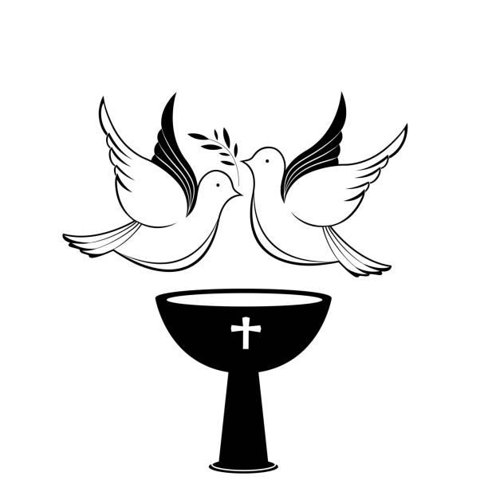
Come and celebrate our Confirmands on Sunday, April 23rd during worship services!
At MN Valley Lutheran there will be donuts/lemonade/coffee in honor of the confirmands, Kaci Tweet and Alexis Cam after church. Also, NO Sunday School on Easter Sunday or Confirmation Sunday at MN Valley.

Shaye Arnold, Leo Borstad, and Lane Schirm will be confirmed at Zion at 10:30am. Come and show them your support!

Time Change starting in May (Borgund & MN Valley)
-8:30am Borgund Worship
-10:30am MN Valley Worship
_________________________________________________________

Easter Lilies
- Given in memory of Deloris Roggatz from Bob Roggatz and their family.
- Given by Al and Diane Jensen in memory of all our loved ones
- Given by Greg and Kathy Tweten in memory of loved ones
- Given by the ZLCW
- Given by Craig and Connie Stotesbery
- Given by Floyd Eliason in memory of all loved ones
- Given by Laura Thomson family, and Hannah Strand family in memory of Jim & Bonnie Vaala
- Given by Kevin and Kathy Skjei in loving memory of Shirley & Severt Mitteness, and Bervin & Arline Skjei.
- Given in memory of Zoe Kittelson, niece of Cindy & Chris Carl & cousin of Gavin and Ashton.

